Guha Dharmarajan  Ramanujan Fellow  Dept: Biological Sciences  E-mail: guha [at] iiserkol.ac.in  Complete CV: Click Here | 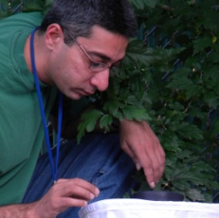

Research Interest:
Theoretical and empirical aspects of population biology and disease ecology.
Academic Background:
- Ph.D. (2008): Department of Forestry and Natural Resources, Purdue University, Indiana, USA.
- M.V.Sc. (2000): Department of Wildlife Science, Tamil Nadu Veterinary and Animal Science University, Tamil Nadu, India (2000).
- B.V.Sc. (1997): Tamil Nadu Veterinary and Animal Science University (1997).
Positions:
- Ramanujan Fellow (Sept. 2012 – Present): Indian Institute of Science Education and Research-Kolkata.
- Post-doctoral Visiting Fellow (Feb. 2011- Aug. 2012) Laboratory of Malaria and Vector Research, National Institute of Allergy and Infectious Diseases, National Institutes of Health, Rockville, Maryland. USA.
- Post-doctoral Research Associate and Member of the Graduate Faculty (Sept. 2008 - Jan. 2011): Department of Forestry and Natural Resources, Purdue University, West Lafayette, Indiana, USA.
Recent Awards and Honors:
- Ramanujan Fellowship (Sept. 2012-2017): Dept. of Science and Technology, Govt. of India.
- Post-doctoral Visiting Fellow Award (Jan. 2011- 2013): National Institutes of Health, USA.
Recent Publications:
- Dharmarajan G, Beatty WS and Rhodes OE Jr. (2013) Heterozygote deficits caused by a Wahlund effect: dispelling unfounded expectations. Journal of Wildlife Management 77: 226–234
- Dharmarajan G, Beasley JC, Fike JA, Raizman EA, Wu CC, Pogranichniy RM and Rhodes OE Jr. (2012) Effects of kin-structure on disease dynamics in raccoons (Procyon lotor) inhabiting a fragmented landscape. Basic and Applied Ecology 13: 560-567.
- Dharmarajan G, Beasley JC and Rhodes OE Jr. (2011) Heterozygote deficiencies in parasite component populations: An evaluation of interrelated hypotheses in the raccoon tick, Ixodes texanus. Heredity 106: 253-260.

